Courses in 2016 spring semester in CEFMS
1. 春季开设16门课程
Courses Teachers
Econometrics II Prof. Haizheng Li, Prof. Xiaojun Wang, Prof. Hongyi Li,
Derivatives Securities Prof. Wei Huang
Econometrics III Prof. McCarthy Patrick
Mathematical Economics Prof. Zhenhui Xu
Corporate Finance Prof. Qianqiu Liu
Investments Prof. Qianqiu Liu
International Trade Prof. Zhenhui Xu
Time Series Analysis Prof. Hongyi Li
Research Methods in Finance Prof. Yingmei Cheng
Foundation of Financial Theory Prof. Yingmei Cheng
Security Analysis Prof. Allan Zebedee
Financial Statement Analysis Prof. Xiaojun He
Health Economics Prof. Xue Li
Development Economics Prof. Yaqin Su
Labor Economics Prof. Si Wang
- 选课时间：开学（学校规定时间）
- 选课方式：研究生选课系统
4. 课程特点：
（1）全英文教学，本课程完全按照美国高校教学方式进行教学；
（2）任课教授都是美国高校的终身教授或拥有海外博士学位的教授；
（3）课程为48学时，3学分；
（4）每门课程不超过50人；
（5）每门课程都有平时作业与测试；
（6）每门课程都有期中与期末考试；
（7）期末考试前每位学生将对任课教师进行教学评价。

Introduction for professors
Visiting Professors
Dr. Haizheng Li
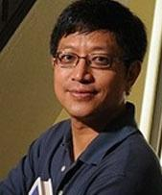
Professor, School of Economics, Georgia Institute of Technology
Areas of Specialization: applied econometrics, labor economics, and Chinese economy.
http://www.econ.gatech.edu/people/person/fe161b52-7155-5aa6-8ec0-d30e4f9554ed

Dr. Xiaojun Wang
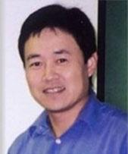
Associate Professor, Department of Economics, University of Hawaii at Manoa
Areas of Specialization: monetary economics, Chinese labor market transition and education returns.
http://www2.hawaii.edu/~xiaojun/

Dr. Wei Huang
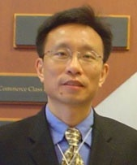
Professor of Finance, Shidler College of Business, University of Hawaii at Manoa
Areas of Specialization: empirical asset pricing, investments, international finance, and Chinese financial markets and corporate governance.
http://www.shidler.hawaii.edu/directory/victor-wei-huang/fei

Dr. Qianqiu Liu
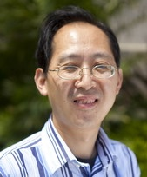
Professor of Finance, the Shidler College of Business, University of Hawaii at Manoa
Areas of Specialization: empirical asset pricing, financial econometrics, market microstructure, personal financial planning, and international finance.
http://www.shidler.hawaii.edu/directory/qianqiu-liu/fei
Dr. Patrick McCarthy
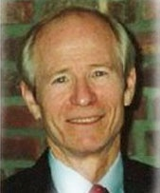
Professor, School of Economics, Georgia Institute of Technology
Areas of Specialization: transportation economics, applied econometrics, industry studies, regulation.
http://www.econ.gatech.edu/people/person/c89b04bc-4f7c-5a5f-84d1-f3204d61d630

Dr. Zhenhui Xu

Professor of Economics, College of Business, Georgia College & State University
Areas of Specialization: international trade and finance and issues concerning economic development and the Chinese economy.
http://www.gcsu.edu/business/economics/facultystaff

Dr. Hongyi Li

Associate Professor, Dept of Decision Sciences and Managerial Economics, Faculty of Business Administration, The Chinese University of Hong Kong
Areas of Specialization: Econometrics, applied macroeconomics and applied finance.
http://www.bschool.cuhk.edu.hk/index.php/schools-departments/decision-sciences-mangerial-economics/faculty/full-time-faculty?pid=692&sid=260:Li-Hongyi

Dr. Yingmei Chen
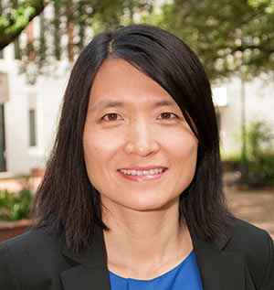
Professor of Finance, College of Business, Florida State University
Areas of Specialization: Stock purchases, executive compensation, cash holdings, R&D investment and international investment.
http://business.fsu.edu/faculty-and-staff/academic-departments/academic-departments-home/Detail/yingmei-cheng


Dr. Allan Zebedee
Associate Professor of Economics and Financial Studies, Schoool of Business, Clarkson University
Areas of Specialization: corporate finance issues, such as initial public offerings, share repurchase programs, stock splits and secondary market activity for syndicated loans.
http://www.clarkson.edu/business/faculty/zebedee.html

Full-time Faculty
Dr. Xiaojun He (Syracuse University)

Associate Professor, Finance
Areas of Specialization: empirical asset pricing, financial econometrics and market microstructure.
http://cefms.hnu.edu.cn/index.php?c=article&id=269

Dr. Xue Li (Louisiana State University)

Assistant Professor, Economics
Areas of Specialization: applied microeconomics, population economics, labor economics and health economics.
http://cefms.hnu.edu.cn/index.php?c=article&id=61

Dr. Yaqin Su (State University of New York at Buffalo)

Assistant Professor, Economics
Areas of Specialization: economic growth and development, applied econometrics and economics of education.
http://cefms.hnu.edu.cn/index.php?c=article&id=60

Dr. Si Wang (University of South Carolina)

Assistant Professor, Economics
Areas of Specialization: labor economics, the economics of education, and applied microeconomics.
http://cefms.hnu.edu.cn/index.php?c=article&id=337

